Configuring PAT or NAT overload

Configure PORT ADDRESS TRANSLATIONS

Inacio Andre

2024

// TOPOLOGY //

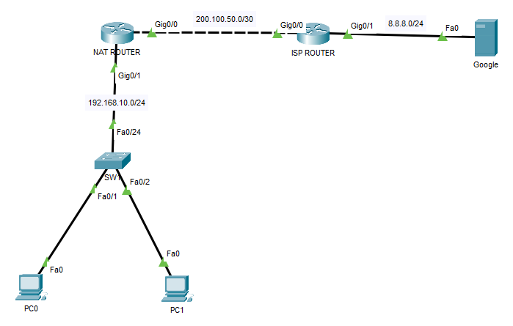

// BASIC CONFIGURATION //

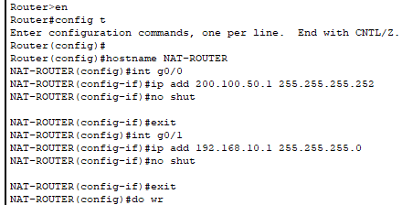

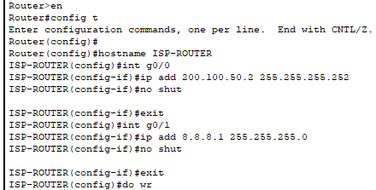

// OSPF ROUTING CONFIGURATION //

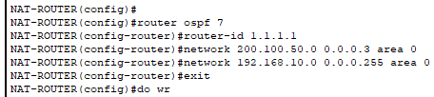

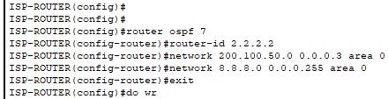

// TESTING COMMUNICATION BEFORE PAT //

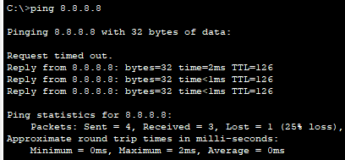



// PAT CONFIGURATION //

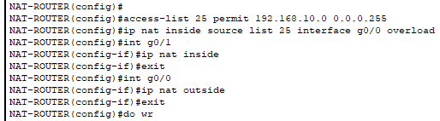

// TESTING PAT CONFIGURATION //

